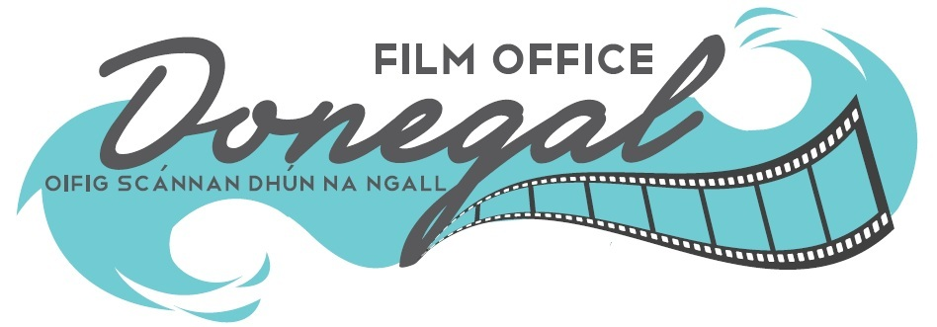

Emerging Talent Fund 2026

This Fund is awarded by Donegal County Council & The National Creative Ireland Programme and aims to foster talent, creativity, and activity in filmmaking in County Donegal. A grant of €10,000 will be awarded to an emerging team towards the cost of producing a short drama or documentary film of 10-12 min duration, to be shot in Donegal in 2026.

GUIDELINES

We are seeking proposals and applications from filmmakers who have a script that has been developed, reviewed by a director, and has received input from a producer. The Talent Fund is a €10,000 grant towards the cost of production.

We are seeking original, entertaining stories from talented filmmakers who, if selected, must set and shoot their project in County Donegal. The Donegal Film Office, based in Donegal County Council, will provide location support and guidance as requested, particularly in accessing locations and local resources.

The closing date for receipt of applications is set at 4 pm on 10th April 2026

Selection Process:

This is a two-stage open competition opportunity.

Stage One: Shortlisting from the applications received.

Stage Two: Application reviews will take place throughout April 2026, and shortlisted applicants may be invited to pitch their projects to a panel.



What We Require:
- A fully completed Application Form.
- A synopsis of the project (500 words max.) including a general plot outline.
- A copy of the full script (without the writer’s name).
- A project plan in terms of general shoot requirements.
- Insights about the script from the Director and the Producer.
- A Financial Projection including all costs, including the potential bursary award.
- A Revenue Access Number from the Irish Revenue Commissioners.
- Confirmation that you have full legal access to the script you are submitting.

Applications should be emailed to filmoffice@donegalcoco.ie by 4.00 pm on 10th April 2026. All submissions made on time will be emailed confirmation of receipt. The Project must be completed and funding drawn down by Friday, 25th September 2026 at 12 noon.

Award Guidelines & Conditions:

- High-quality propositions are encouraged from filmmakers who have developed a capacity in filmmaking.
2. One of the core creative team (Writer/Director/Producer) must be emerging and from Donegal or living in Donegal. (Proof of personal address will be required from shortlisted applicants.
3. Applicants must have a short drama script or documentary treatment of 10-12 minutes in duration with a keen interest in shooting in Donegal. The guidance on film length and duration is 10-12 minutes. Film suggestions longer than 15 minutes are not eligible to apply.
4. Applicants must have full legal rights to the material they are submitting.
5. Applications must show seriousness in terms of intent and ambition for the award. Applications need to include a 500-word synopsis of the project, including a general plot outline, a full script, a project plan outlining general shoot requirements, and insights from a director and a producer. Applications need to demonstrate awareness of Donegal as a filming location.
6. A maximum of three applications per person/organisation or legal entity will be accepted. A separate application must be submitted for each application.
7. Opportunities to have the film screened in Donegal will be generated.
8. Donegal County Council, as the local statutory body of the State, cannot undertake to support a proposition that would conflict with its mandate as a local authority.
9. Short Dramas that need significant additional finance, have been part-shot or have been shot entirely are not eligible to apply.
10. The Emerging Talent Fund is limited to a maximum of €10,000. If a balance of funds is required, the source must be clearly identified and detailed in your proposal. The maximum additional funds must not exceed €10,000. Any additional funding or personnel associated with the film must be agreed in advance with the Emerging Fund management team.
11. The shoot must take place in Donegal, and the location manager must connect with the film office to discuss locations and submit a filming application form. This form is available from the film office, and details of insurance/risk assessments etc., must be submitted in advance of the shoot. Applicants should be able to complete production, including all post-production, in 2026.
12. If a production has not commenced within three months of Donegal County Council announcing the successful applicant, then Donegal County Council retains the right to give the award to number two on the panel.
13. All applicants must have an Irish Revenue Access Number (old Tax Clearance Certificate) from the Office of the Revenue Commissioners in Ireland and must include this with their application.
14. Codes of Practice Observance; Child First Guidelines, including appropriate Garda Vetting procedures, Health & Safety Regulations, Equal Opportunities policies and procedures, must be in place and adhered to where relevant and in all cases.
15. Donegal County Council, Donegal Film Office & The National Creative Ireland Programme must be acknowledged by the promoter/applicant on all websites and social media platforms, publicity, press, and marketing material produced in connection with the Film and Film Award.
16. Donegal County Council’s logo, Donegal Film Office Logo & The National Creative Ireland Programme logo must be included in the final cut, in all associated printed material, on posters, flyers, etc., and on all websites. Copies of all such material produced must be sent to the Donegal Film Office for approval and filing. Logos can be requested from Donegal Film Office.
17. Please note that Donegal County Council reserves the right not to award the funding if none of the applications received is deemed to be suitable. In this instance, Donegal County Council reserves the right to pursue a different procurement process.
18. Eligibility and compliance with these guidelines and conditions does not guarantee receipt of an award.
19. Acceptance of these conditions and guidelines is implied by submission of an Application to the Emerging Talent Fund 2026.

Freedom of Information: Donegal County Council proposes that the following information relating to this Emerging Talent Fund application will be made available upon request: the name (s) of the successful applicant (s) and/ or the reason/s an applicant did not qualify for grant consideration. Donegal County Council undertakes to use its best endeavours to hold confidential any information provided by applicants subject to its obligations under law, including the Freedom of Information Act 1998 and 2003. Applicants are requested to consider whether any of the information supplied should not be disclosed because of its sensitivity. If this is the case, candidates should, when providing the information, identify the same and specify the reasons for its sensitivity. If such information is not identified as sensitive and Donegal County Council, upon consideration, does not deem it sensitive, then such information is liable to be released in response to a Freedom of Information request without further consultation with the applicant. Donegal County Council will consult with any candidates about sensitive information before deciding on any Freedom of Information Act request received.
Donegal County Council welcomes submissions to the Emerging Talent Fund from all applicants, regardless of gender, sexual orientation, age, ethnicity, Traveller community membership, disability, religion, family status or socio-economic background, and is committed to equal opportunity for all applicants. The Council is keen that submissions to the Fund reflect the diversity of Donegal's communities.

