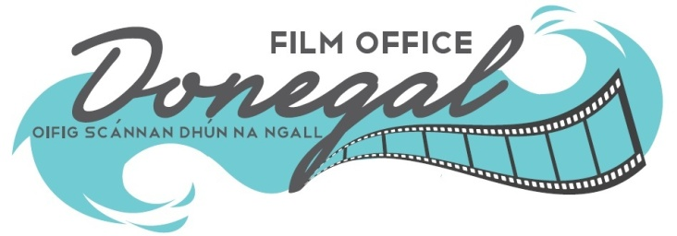
Short Film Bursary
Application Form 2024

Please email the following to filmoffice@donegalcoco.ie
SHORT DRAMA FILM  - A fully completed application form.  - A copy of the script  (NB no name on script).  - A 500 word (max) synopsis of the script. |  | SHORT DOCUMENTARY FILM  - A fully completed application form.  - A comprehensive documentary. treatment (including contributers & narrative approach).  - A 500 word (max) documentary synopsis.
NB : Closing Date – 4.00pm Friday 29th March 2024
APPLICANT DETAILS:
Lead Contact:
Role in the Project:
Company name if relevant
Address:

Website:
Telephone:
Mobile:
Email:
PRODUCTION DETAILS:
Script Title:
Scriptwriter’s name:
Scriptwriters email:
Producer’s name:
Producer’s email:
Director’s name:
Director’s email
DOP’s name (if attached)
Members of the Core Creative Team (Writer/Director/Producer) who are living in Donegal:

Brief summary of Writers Experience:

Brief summary of Directors Experience:

Brief summary of Producers Experience:

Insights/Comment from the Director & Producer regards suitability of the script for production:

OPERATIONAL DETAILS:
To the best of your ability please provide details on the number & type of crew that will be involved in the production

Actors ______ Production Mgr(s) _____

Camera Operators _____ Line Producer ______

Sound Technicians _____ Makeup & Costume _____

Location Mgr ______ Other ______

Please describe briefly details of Post-Production:

Please describe briefly your process with regard to Health & Safety and Risk Assessment:

Please describe briefly the range & type of film locations in Donegal that appeal to you and might be relevant to you filming in Donegal:

Please provide an outline project plan with regard to your general shoot requirements:

FUNDING INFORMATION
Please provide a financial projection including all costs. Include the bursary amount of €10,000 in your budget outline. Please indicate the source of all funds & state if they are confirmed (letters of confirmed funding can be attached/included as relevant):

Revenue Access Number: ___________________________________

Please sign here to confirm you have full legal clearance to the script:

Print Name : ___________________________ Signature : __________________________

CHECKLIST:

Please ensure you have submitted the following via email:

- A fully completed application form.
- A copy of the script (no name attached).
- A 500 word summary.
- A current Revenue access number (old tax clearance cert).
- Evidence that you have full legal clearance to the script you are submitting.



‘Donegal County Council welcomes submission to the Film Bursary Call from all applicants regardless of their gender, sexual orientation, age, ethnicity, membership of the Traveller community, disability, religion, family status or socio-economic background and is committed to equal opportunity for all applicants. The Council is keen that submissions to the Film Bursary /Call reflect the diversity of communities in Donegal.

